This demo will create 2 schema called Internet and Instore

- Step1: Right click on Schemas in Security of Fsoft_Training database and choose New Schema...
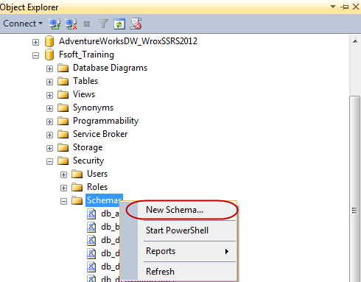
- In Schema dialog enter Internet in Schema name textbox and click OK

